Vision in Primates
During the previous lessons you’ve learned about the visible light spectrum as it relates to the human visual system; however, not all animals have a visual system similar to humans. In fact, many species have visual systems much different than that of humans. The following article discusses a few of the different visual systems present in primates. While reading the article, consider other possible visual systems in animals, as well as how it might affect their perception of their environment.
Monkeys and Humans See Differently, Experts Say
Bijal P. Trivedi
National Geographic On Assignment
November 26, 2003
Monkeys and their human cousins don't necessarily see the world the same way, according to new research from the Peruvian Amazon and a clever experiment from a lab in Scotland.
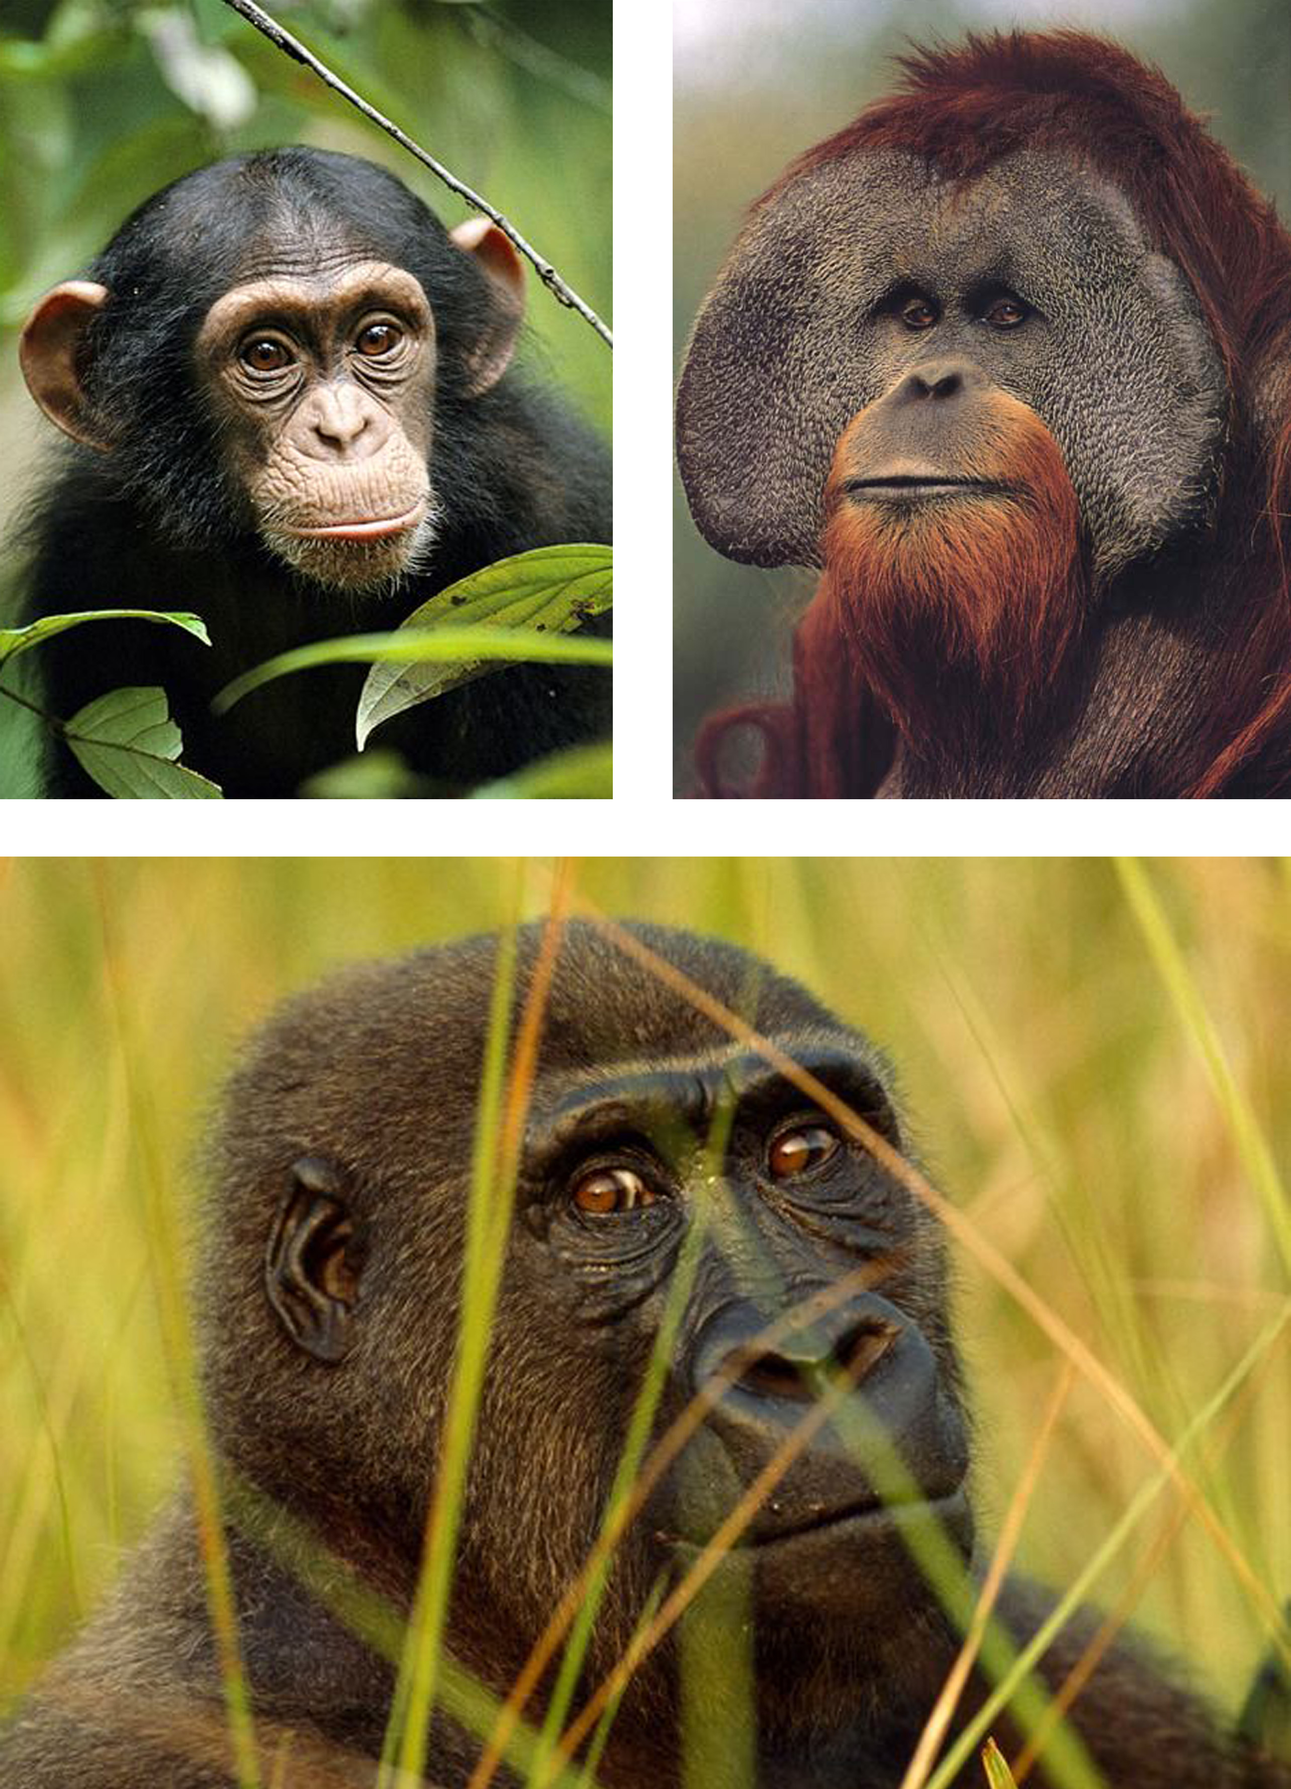
In fact, some monkeys, even within the same species, see things differently from one another. The research suggests that various forms of sight may confer a range of survival advantages.
"As humans, we tend to think all creatures perceive the world the way we do, but that isn't the case," said Andrew Smith, a primatologist at the University of Stirling in Scotland.
For nearly a decade, Smith and his colleagues have ventured into the Peruvian Amazon to study how different types of sight affected the foraging behavior of New World monkeys called tamarins.
Humans have so-called trichromatic, or three-color, vision. So do Old World species such as chimpanzees, gorillas and orangutans. Trichromats have three types of light sensitive cells in the retina, fine-tuned to wavelengths that appear blue, green and red.
But New World monkeys have a broad range of vision types. Every howler monkey, for example, is trichromatic. The owl monkey is monochromatic, seeing only in black and white. Among tamarins and spider monkeys, all males are dichromats—they can't perceive reds or greens. But females split 60-40 between three- and two-color vision.
Chimpanzees (top left), Orangutans (top right), and Gorillas (bottom) all possess trichromatic vision similar to humans.
"You can have six individuals from the same species, even the same family, who see the world in six different ways," Smith said.

Tracking Tamarins
Like the one in 12 men who are colorblind, many New World monkeys have trouble discriminating between red and green, which can hamper the animals' ability to tell ripe fruit from raw.
Smith and his colleagues prowled the forests to follow the tamarins as they jumped from tree to tree high in the canopy. With a spectrometer, Smith measured the color of the fruit and the leaves on which the tamarins feed.
Tamarins eat the fruit of more than 833 plants from 167 different species. A favorite is the Abuta fluminum plant.
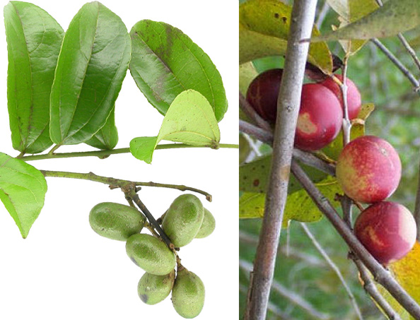
Ripe Abuta is orange, like other fruits that the tamarins like. But orange is hard to detect without red-green perception.
Back in Britain, Smith devised his experiment to give the tamarins an eye-test. At the Belfast Zoological Garden in Ireland, he simulated the forest canopy on a wire scaffold decked with large green paper leaves that roughly matched the color of Abuta.
Among the leaves he scattered small cardboard boxes with lids whose color matched the shades of Abuta fruit from a raw green to a ripe orange. The "ripe" boxes concealed large chunks of fudge, the less ripe, smaller chunks. "Unripe" boxes were empty.
Note the color difference between unripe Abuta (left) and ripe Abuta (right). Ripe Abuta fruit is much more nutritious.
Then the researchers guided male and female saddleback and red-bellied tamarins (Saguinus fuscicollis and Saguinus labiatus) into the enclosure, one by one, to forage for the "ripe fruit."
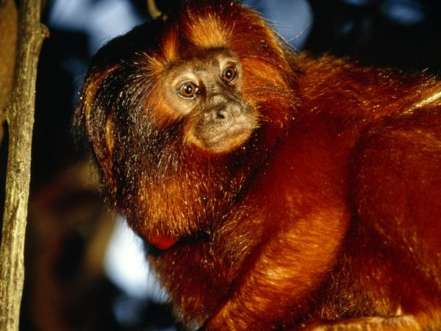Trichromat tamarins, as it turned out, were 50 percent more adept at choosing the ripe fruit than their dichromat fellows.
This male Golden-lion Tamarin, like all male tamarins, has cone cells primarily activated by green and blue light, making it difficult to perceive the color red.
Advantages of Two-Color Vision?
"(Smith's) findings are very strong," said Nathaniel Dominy, a primatologist at the University of Chicago in Illinois. "He is the first person to show that there is an advantage to trichromacy in New World monkeys—they are clearly better at finding and distinguishing ripe fruit."
In 2001 Dominy published his study of four species of Old World apes and monkeys in Uganda—chimps (Pan troglodytes), black-and-white colobus (Colobus guereza), red colobus (Piliocolobus badius), and red-tailed monkeys (Cercopithecus ascanius). Tricromatic color vision, Dominy determined, was essential for choosing tender young red leaves—more digestible and nutritious than the more mature green ones.
"Smith's work shows that it is definitely better to be a trichromat," said Gerald Jacobs, an expert on mammalian color vision at the University of California, Santa Barbara. "Dichromats have a real visual deficit and clearly don't do as well in the world."
For example, some forms of dichromacy entail less sensitivity to light, making the world appear dimmer.
A mystery for the scientists is why, if trichromacy is so advantageous, it hasn't replaced dichromacy altogether in the evolution of primates.
"There may be some unidentified advantages to being a dichromat," Dominy said.
Smith's preliminary results suggest that dichromats may be better at "breaking the camouflage of predators and prey," he said. New World monkeys, in addition to fruit, also consume large quantities of prey—katydids, frogs, and lizards.
"Perhaps dichromats are not as distracted by colors and better at seeing shapes and forms," Smith said.
Nature endows each way of seeing. Trichromats may be better at finding fruit; dichromats, at catching prey.

Photo Credits
- Page 1:
  - Orangutan image – Columbia.edu
  - Chimp and Gorilla images – Nationalgeographic.com
- Page 2:
  - Golden-lion tamarin image – nationalgeographic.com
Questions
- Do all primates have the same type of color vision? Explain your answer.

- If primates have different types of color vision, do you think that there could be other visual systems in more distantly related species? Why?

- According to the article, what is one hypothesized advantage to dichromacy over trichromacy?

- How would you design an experiment to test the hypothesis?

